**Reintroduction of Golden Paintbrush (*Castilleja levisecta*) to the Willamette Valley**

*By Patrick McCornack*

11/19/2020

# Introduction

*Castilleja levisecta*, commonly known as golden paintbrush, is an endangered hemiparasitic plant endemic to the Pacific Northwest. It is a perennial with many stems that branch out from the base. The stems are up to 50 cm tall and are topped with a sturdy yellow inflorescence from which the name is derived (Oregon Department of Agriculture n.d.). *C. levisecta* once inhabited lowland prairies in western Oregon, western Washington, and southwestern British Columbia (Lawrence et al. 2006). There are now only 11 extant populations remaining within Washington and British Columbia and the species is listed as federally endangered (Dunwiddie and Martin 2016; Lawrence et al. 2011). The decline of *C. levisecta* is largely due to the decline of lowland prairies as historic habitat was converted to agriculture or threatened by invasive annual grasses (Delvin 2013). *C. levisecta* has been extirpated from its southern range in the Willamette valley of Oregon since 1938 and today less than 1% of native prairie habitat remains (Christy and Alverson 2011; Lawrence and Kaye 2006). However, abandoned agricultural fields may offer highly suitable habitat for the reintroduction of *C. levisecta* through proper restoration efforts.

# Ecology of *C. Levisecta*

## Current and Historic Habitat

The extant populations of *Castilleja levisecta* are found only on sandy, well-drained soils of glacial origin (Lawrence and Kaye 2008). These sites are found near rocky bluffs, gravelly prairies, and other sites otherwise not suitable for agriculture (Godt et al. 2005). Lowland prairies with deep and fertile soils were the first to be converted to agriculture by European settlers. Extant sites likely are not completely representative of the native habitat of *C. levisecta* but are rather low-quality sites that survived the conversion to agricultural lands due to their unsuitability for growing crops (Dunwiddie and Martin 2016). Herbarium records collected from historic sites in the Willamette valley reference specimens collected from “wet meadow” and “damp, open ground” suggesting that *C. levisecta* is not restricted to well drained soils (Lawrence and Kaye 2006). *C. levisecta* specimens sown in deeper soils have been found to perform better than specimens growing in current conservation sites representing poorer habitat (Dunwiddie et al. 2016). The results of a study comparing the effect of microsites on the survival of outplanted *C. levisecta* specimens suggest that plants established in deeper soils have a significantly greater survival rate than those established in rocky prairie soils (Dunwiddie and Martin 2016). These results indicate that sites with deeper soils may have a high potential for the reintroduction of *C. levisecta*, but the majority of historic lowland prairie sites with deep soils in the Pacific Northwest have been converted for agricultural use (Christy and Alverson 2011). However, over the last several decades the intensity of agricultural and forestry related land use has been declining (Wilson and Sorenson 2012). These abandoned agricultural fields may provide high quality sites for restoration to native grassland due to their deep and fertile soils. Delvin (2013) demonstrated that extremely large populations are capable of establishing in such abandoned agricultural sites. These severely degraded sites should be a primary focus of *C. levisecta* reintroduction to the Willamette Valley.

## Ecosystem Role as a Hemiparasite

*C. levisecta* is a hemiparasite and can form haustorial connections to host plants to obtain nutrients, water, and secondary compounds (Lawrence and Kaye 2013). It is photosynthetic and does not require a host but will perform better if it parasitizes other plants (Schmidt 2016). Not only the presence of a host, but the identity of the host may also play a significant role in the performance of the plant. It was found that *C. levisecta* plants grown with the host *Eriophyllum lanatum* not only increased second-year survival rates for outplanted specimens but increased seed production compared with plants grown with *Festuca roemeri* as the host (Delvin 2013). This could indicate that different hosts provide different qualities of nutrients. As a generalist parasite, *C. levisecta* seems to utilize a wide range of hosts with each host conferring variable but typically positive influences (Schmidt 2016).

Research on the suitability of a wide range of potential hosts is lacking, but there is a positive correlation between native perennial diversity and *C. levisecta* success (Dunwiddie and Martin 2016; Schmidt 2016). There seems to be a negative correlation between the presence of annual forbs and invasive annual grasses and *C. levisecta* presence, but host diversity may be less important in productive soils (Dunwiddie and Martin 2016). This could be because *C. levisecta* is less dependent on parasitizing resources when they are abundant in the environment. Based on this, potential reintroduction sites should have either a high species diversity of perennial forbs or high-quality, deep soils.

As a hemiparasite, *C. levisecta* may play an influential role in structuring native lowland prairie communities. Another hemiparasite, *Pedicularis kansuensis*, was found to alter competitive relationships and increase species diversity in the grasslands of the Qinghai-Tibet Plateau. By parasitizing the more dominant grasses the presence of *P. kansuensis* allowed less competitive species to establish (Bai et al, 2015). Hemiparasites may also indirectly influence community structure through facilitating rapid nutrient cycling through dropping nutrient-rich litter. This can create heterogeneity within the habitat by creating nutrient-rich patches which contribute to increase biodiversity (Fisher et al. 2013). The effect of *C. levisecta* on plant communities is less well established, but it does seem to influence the plant community structure within its habitat in some cases (Schmidt 2016). *C. levisecta* is also a host for Taylor’s checkerspot butterfly, an endangered species that is endemic to the Pacific Northwest that utilizes *C. levisecta* as a larval food source (Dunwiddie et al. 2020). Reintroducing *C. levisecta* to Willamette Valley would serve the joint purpose of synergistically assisting in the recovery of Taylor’s Checkerspot and playing a key role in the restoration of native grasslands.

# The Willamette Valley

The area targeted for reintroduction of *C. levisecta* is the Willamette Valley ecoregion of the Pacific Northwest. Occurring between the Coast Range and Cascade Range, the Willamette Valley is mostly situated within northwestern Oregon (Figure 1). The Willamette River runs through the center of the valley and the topography of the valley mostly flat. The climate is mild and the soils are deep and nutrient-rich. Much of the valley has been converted for use by the agricultural and forestry industries (Wilson and Sorenson 2012).

During the 1850’s, shortly after European settlement, a large portion of the valley was native prairie and white-oak savannah (Figure 2). The majority of the prairie would have been classified as upland prairie (Christy and Alverson 2011). Upland prairie and white-oak savannah vegetation classes are the primary habitats typically associated with *C. levisecta* (Lawrence and Kaye 2011). These prairies and savannahs were maintained by fires set by the Native Americans at intervals of 1-2 years (Christy and Alverson 2011; Johannessen et al. 1971). These regular prairie fires maintained the open structure of the savannah and woodlands and prevented the encroachment of woody plants into the prairies (Johannessen 1971). When Europeans settled the area, the structure of the landscape began to change drastically; what was once prairie, savannah, and woodland is now dominated by agriculture (Wilson and Sorenson 2012).

Historically *C. levisecta* ranged from the Willamette Valley up through the Puget Trough and into the southwestern portion of Canada (Lawrence and Kay 2006). Presumably, it was widely distributed within the valley based on historic vegetation cover, but it is now believed to extirpated in Oregon with no natural occurrences having been sighted since 1938 (Godt et al. 2005). The main contributors to the demise of *C. levisecta* in the Willamette Valley have been the conversion of native prairie to agricultural land and the introduction of aggressive exotic grasses (Lawrence and Kaye 2011).

# Reintroduction

*Castilleja levisecta* will be reintroduced to the Willamette Valley using direct seeding methods in abandoned agricultural fields. These sites may represent some of the best habitat for *C. levisecta* but will require working closely with the community for long-term protection of established populations. Direct seeding is less costly than outplanting plugs and requires less detailed knowledge about the multitude of interacting characteristics of the site.

Direct seeding of *C. levisecta* in abandoned agricultural land has been shown to have the potential to produce extremely large populations (Delvin 2013). These lands typically have deep and fertile soils and are situated where *C. levisecta* likely inhabited before the prairie was converted to agriculture. Production beds for *C. levisecta* seeds have made direct seeding a much more viable method by increasing seed abundance (Dunwiddie et al. 2013). Seeds are also much cheaper than *C. levisecta* plugs at $.30 per 1000 seeds vs. $3.00 per plug (Dunwiddie et al. 2016). Direct seeding does not necessitate detailed knowledge about suitable microsite conditions and instead allows the practitioner to cheaply distribute the seed over large areas to allow the plant to take hold where suitable conditions exist. Outplanting requires the practitioner to carefully select each microsite where plugs are to be planted and relies on a small population of plugs to successfully establish and reproduce to successfully create a resilient population.

Since the majority of the best sites for reintroducing *C. levisecta* lay on private land there is a need for cooperation between governmental agencies and private landowners as well as with non-governmental organizations. The Willamette valley has a history of successful conservation partnerships that have restored and protected both wildlife populations and habitats (U.S. Fish and Wildlife Service 2017). Efforts to restore *C. levisecta* to the Willamette Valley should similarily rely on such public/private partnerships with private abandoned agricultural fields being the focus of the cooperation.

Once a site has been identified and access has been gained the land must be prepared prior to seeding. Prescribed fire in the summer prior to seeding as a pre-treatment has been shown to increase the chance that *C. levisecta* seed successfully germinates and establishes (Delvin 2013). Extant populations that have been burned also have shown evidence of higher post-burn recruitment rates than unburned populations (Dunwiddie et al. 2001).

The site will be pre-treated with burning in the summer prior to seeding. Following the work of Delvin (2013) that resulted in 3-5% germination rates, the ground will be harrowed immediately prior to seeding and raked after seeding. While overall establishment rate is low, it seems that a seed density between 150 and 1,000 seeds per square meter is ideal (Delvin 2013). As a hemiparasite, *C. levisecta* should be densely sown with a mixture of native grasses and forbs. While the presence of these hosts appears not to be needed for seedling establishment, they will certainly play a role in seedling persistence (Delvin 2013). *C. levisecta* has a long germination period, ranging from spring to late summer, and the first summer is a critical period for seedlings (Dunwiddie et al. 2001). Water is scarce in the region during the summer and additional water treatments during this first summer has been shown to increase seedling survival. These plants can then generally survive without additional watering treatments after this period of time (Dunwiddie et al. 2001). Survey of *C. levisecta* populations should be completed while the plant is flowering from late April to early June (Oregon Department of Agriculture n.d.).

After seedlings have been allowed to establish, prescribed burning should be used every 1-2 summers to maintain sites. Before settlement by Europeans, the Native Americans maintained the prairies of the Willamette Valley with prescribed fire set every 1-2 years (Christy and Alverson 2011). *C. levisecta* has been shown to respond favorably to burning and it has the added benefit of maintaining a low and open vegetation structure and potentially removing invasive species (Dunwiddie et al. 2001).

# Summary and Future Directions

This reintroduction plan aims to establish large populations of Castilleja levisecta within its historic range in the Willamette Valley of Oregon, where it is currently extirpated. The focus of reintroduction will be on abandoned agricultural lands due to their deep and fertile soils. Reintroduction will be accomplished by direct seeding of these sites using a seed mixture of *C. levisecta* and native grasses and forbs which has the added benefit of creating communities with similar compositions to what historically occupied the lowlands of the valley. This work will require collaboration between public or non-governmental organizations and private landowners to be successful.

Further conservation efforts with *C. levisecta* should focus on establishing populations on land that is already currently under federal protection. This will ensure the longevity of established populations. A focus for this could be white-oak savannah, some sites of which already have federal protection and are historically associated with *C. levisecta* populations in the Willamette Valley.

# Citations

Bao, G., Suetsugu, K., Wang, H., Yao, X., Liu, L., Ou, J., & Li, C. (2015). Effects of the hemiparasitic plant *Pedicularis kansuensis* on plant community structure in a degraded grassland. *Ecological Research*, *30*(3), 507-515.

Boyer, L. (2008). Providing Native Plant Diversity to the Willamette Valley Ecoregion No-tech, low-tech, and old-tech seed production methods. *Native Plants Journal*, *9*(3), 230-240

Christy, J.A., & Alverson, E.R. (2011). Historical vegetation of the Willamette Valley, Oregon, circa 1850. *Northwest Science*, *85*(2), 93-107.

Delvin EG. (2013) Restoring abandoned agricultural lands in Puget Lowland prairies: A new approach. Ph. D. Thesis. University of Washington.

Dunwiddie, P.W., Davenport, R., & Speaks, P. (2001). Effects of burning on *Castilleja levisecta* at Rocky Prairie Natural Area Preserve, Washington: A summary of three long-term studies. *Conservation of Washington’s Native Plants and Ecosystem,* 161-172

Dunwiddie, P.W., Martin, R.A., & Jarisch, M.C. (2013). Water and fertilizer effects on the germination and survival of direct-seeded golden paintbrush (*Castilleja levisecta*). *Ecological Restoration*, *31*(1), 10-12.

Dunwiddie, P.W., Haan, N.L., Linders, M., Bakker, J.D., Fimbel, C., & Thomas, T.B. (2016). Intertwined fates: opportunities and challenges in the linked recovery of two rare species. *Natural Areas Journal*, *36*(2), 207-215.

Dunwiddie, P.W., & Martin, R.A. (2016). Microsites Matter: Improving the Success of Rare Species Reintroductions. *PloS One*, *11*(3).

Fisher, J.P., Phoenix, G.K., Childs, D.Z., Press, M.C., Smith, S.W., Pilkington, M.G., & Cameron, D.D. (2013). Parasitic plant litter input: a novel indirect mechanism influencing plant community structure. *New Phytologist*, *198*(1), 222-231.

Godt, M.W., Caplow, F., & Hamrick, J.L. (2005). Allozyme diversity in the federally threatened golden paintbrush, *Castilleja levisecta* (Scrophulariaceae). *Conservation Genetics*, *6*(1), 87-99.

Heckard, L.R. (1962). Root Parasitism in Castilleja. *Botanical Gazette (Chicago, Ill.)*, *124*(1), 21–29.

Irving, L. J., & Cameron, D. D. (2009). You are what you eat: interactions between root parasitic plants and their hosts. *Advances in Botanical Research*, *50*, 87-138.

Johannessen, C.L., Davenport, W.A., Millet, A., & McWilliams, S. (1971) "THE VEGETATION OF THE WILLAMETTE VALLEY 1." *Annals of the Association of American Geographers* 61, 286-302.

Kaye, T.N. (2008). Vital steps toward success of endangered plant reintroductions. *Native Plants Journal*, *9*(3), 313–322.

Lawrence, B.A., & Kaye, T.N. (2006). Habitat variation throughout the historic range of golden paintbrush, a Pacific Northwest prairie endemic: Implications for reintroduction. *Northwest Science*, *80*(2), 140.

Lawrence B.A, Kaye T.N. (2008) Direct and indirect effects of host plants: implications for reintroduction of an endangered hemiparasitic plant (*Castilleja levisecta*). *Madroño,* 55, 151–158.

Lawrence, B.A., & Kaye, T.N. (2011). Reintroduction of Castilleja levisecta: Effects of Ecological Similarity, Source Population Genetics, and Habitat Quality. *Restoration Ecology*, *19*(2), 166–176.

Oregon Department of Agriculture. (n.d.). *Golden Paintbrush (Castilleja levisecta).* Retrieved November 3, 2020, from State of Oregon: https://www.oregon.gov/oda/shared/Documents/Publications/PlantConservation/CastillejaLevisectaProfile.pdf

U.S. Fish and Wildlife Service. 2017. Willamette Valley Conservation Study. Pacific Region, Portland, Oregon. 148 pp.

Wilson, T. S., & Sorenson, D. G. (2012). *Willamette Valley Ecoregion: Chapter 3 in Status and trends of land change in the Western United States--1973 to 2000* (No. 1794-A-3, pp. 51-57). US Geological Survey.

# Appendix

Figure 1: Map of the Willamette Valley ecoregion (Wilson and Sorenson 2012)

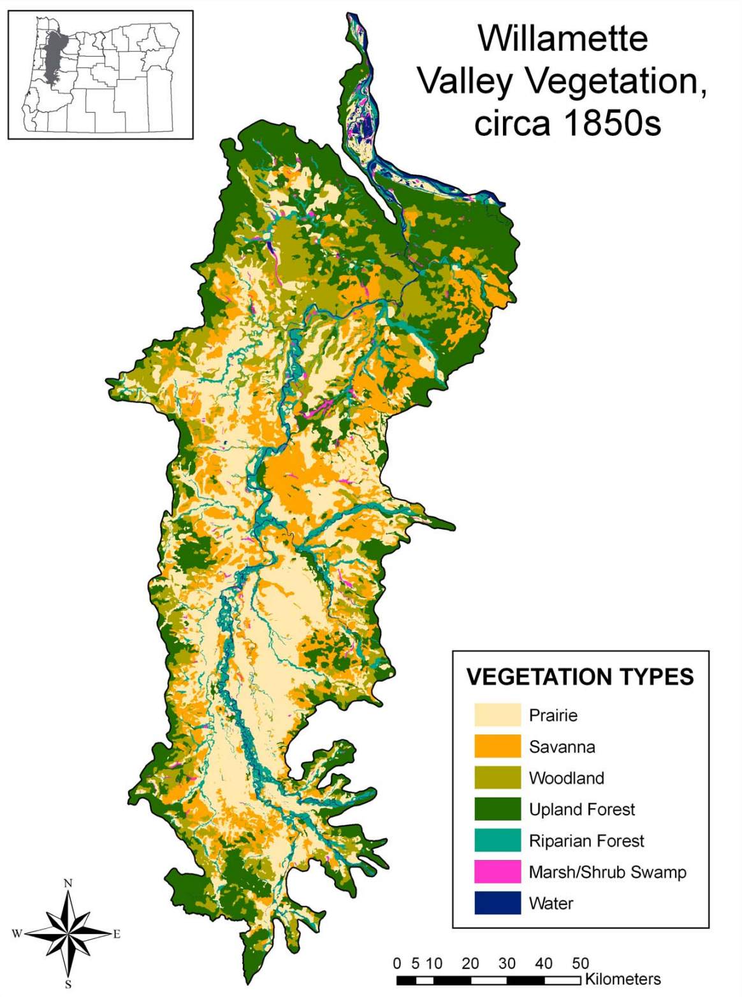Figure 2: Historic vegetation cover in the Willamette Valley (Christy and Alverson 2011)